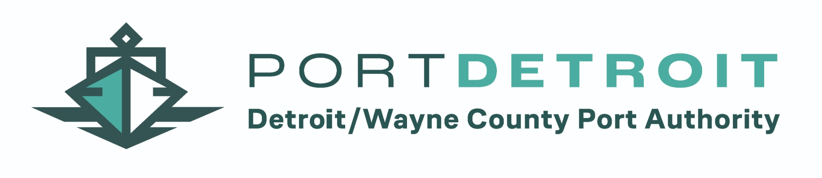

SPECIAL MEETING NOTICE
Commissioner Jonathan C. Kinloch, Chair of the Board of Directors for the Detroit/Wayne County Port Authority, has scheduled a Special Meeting of the Detroit/Wayne County Port Authority Board of Directors on Tuesday, September 29, 2026, at 3:30 p.m. in the Board Conference Room at the Detroit/Wayne County Port Authority, 130 Atwater Street, Detroit, Michigan 48226.
AGENDA
1. Call to Order
2. Approval of the Minutes
3. Renewal of the Midwest and Karoub Contracts
4. Approval of Baker Tilly Contract
5. Proposed Maritime Innovation Terminal Advisory Council
6. Executive Director Interviews and Selection
7. Public Comment
8. Adjournment
As this is a Special Meeting, only the items posted on the agenda may be discussed or acted upon.

